Recommending New Brazilian Steakhouse Locations With Density-Based Clustering

June 2021

Created by

Julius Lerm

Table of Contents

Table of Contents iii

1 Introduction 1

2 Data Acquisition 2

3 Exploratory Data Analysis / Metropolitan Chicago 5

4 Results 8

4.1 Metropolitan Chicago 8

4.2 Downtown Chicago 10

4.3 Downtown Manhattan 11

4.4 Orange County 12

5 Observations 14

6 Conclusions 15

# Introduction

There's a special type of Brazilian steakhouse known as "Churrascaria" in Portuguese. It originated in Southern Brazil and provides a unique experience, when compared to other types of restaurants. The main feature is an "all-you-can-eat" experience where a variety of meat cuts are brought to the table in skewers. Patrons can control the flow of meat with a red/green token placed on the table.

The experience is enhanced with a salad bar (a special for vegetarian patrons), in addition to other menu items. This makes it possible to entertain large groups with varying degrees of appreciation for a carnivore diet. Brazilian steakhouses also tend to offer a large selection of wines and spirits.

Over the course of the previous 15 or 20 years, a number of chains were established in major metropolitan areas and travel destinations across the US.

At least one of them, originally from Brazil, was acquired and is now operated by a US-based company. They kept the same brand name and experience.

Brazilian steakhouses are certainly not a favorite of all Americans, but based on the opinion of colleagues and acquaintances over the years, it's certainly a favorite of a large number of individuals and families. This can be verified by the usual attendance.

Although the number of Brazilian steakhouses increased across the USA over the years, there's still room for more restaurants.

The goal of this study is to investigate geographical areas in the US that show potential for new restaurants of this type.

The following sections present which and how source data is acquired, the data analysis methodology, a reusable function that implements that methodology, and results when applied to different metropolitan areas in the USA.

# Data Acquisition

The data was obtained using the Foursquare API, with a Personal account. We have the following API call limits:

* 99,500 Regular Calls / Day
* 500 Premium Calls / Day
* 2 Photos per Venue
* 2 Tips per Venue

Unfortunately just 2 photos and 2 tips per venue is too little for a larger scale analysis. I restricted the methodology to the venues explore API call (regular):

https://api.foursquare.com/v2/venues/explore

Relevant fields returned by that call are:

* venue.name
* venue.location.address
* venue.location.lat
* venue.location.lng
* venue.location.city
* venue.location.state
* venue.location.country
* venue.categories

The venues explore API is wrapped by a custom Python function get_venues(), that accepts the following input arguments:

* Location array
* Query array
* Prices (comma-separated list of integers, each one in range 1..4)
* Radius (default 10,000 meters)
* Limit (default 200 – in practice, never got more than 99 venues per query)

For each location in the location array, it invokes the API call with each element of the query array.

For example:

locations=['Schaumburg,IL', 'Oakbrook Terrace,IL', 'Wheaton,IL']

queries=['Steakhouse','Shopping Mall','Hotel']

ps='3,4'

r=get_venues(locations,qs,prices=ps)

In the example above, for each of the three locations listed, it executes three queries: for steakhouses, shopping malls and hotels.

With the Foursquare API, the larger the radius, more the results are spread around the specified location. For some locations, the radius can be even greater than 100,000 meters.

If you expect denser results, set the radius to at most 10,000 meters.

This means that in order to obtain maximum density for the results on a metropolitan area, one must search over multiple locations.

For example, to cover most of the Chicago metropolitan area, the following locations are specified:

'Schaumburg,IL',

'Oakbrook Terrace,IL',

'Wheaton,IL',

'Bloomingdale,IL',

'Rosemont,IL',

'Carol Stream,IL',

'Elgin,IL',

'Oak Park,IL',

'Evanston,IL',

'Skokie,IL',

'Brookfield,IL',

'Oak Lawn,IL',

'Orland Park,IL',

'Downers Grove,IL',

'Chicago,IL',

'Naperville,IL',

'Glenview,IL',

'Northbrook,IL'

The result sets are merge and duplicates removed based on venue ID. The above means we don’t have to get down to each and every ZIP code or city.

The function “get_venues()” is encapsulated by a function “rank_locations()”.

The price parameter is suppressed for some of the query strings, such as hotels, shopping malls, plazas and centers. Those types of venues don’t support the price property and if specified, queries won’t return any results.

# Exploratory Data Analysis / Metropolitan Chicago

The approach adopted for the exploratory analysis was based on some assumptions, based on my own experience as a native Brazilian customer. I am not a restaurant owner and never owned or worked at any restaurants before.

Having been to some Brazilian steakhouses in the US, I could observe that they tend to be of a higher price category, and tend to be located in high traffic areas, such as business and entertainment districts, shopping malls and hotels. People may drive from far away for occasional special meals, such as business lunches, birthdays, or any sort of special celebration to which they invite their family members and friends.

K-Means clustering is not really useful for the problem at hand. It doesn’t make much sense dissecting all neighborhoods in certain region and finding similarities among them, for the sake of advising locations for new retaurants of any type. One problem is that some locations absolutely don’t make sense for higher priced restaurants. For example, in neighborhoods that are predominantly residential where businesses are not allowed.

The approach adopted in this work is based on searching venues of specific types across a metropolitan area, where higher priced steakhouses would tend to gravitate around. Using the Foursquare API we search for hotels, shopping malls and steakhouses in a certain region.

Then use density-based clustering to find groups of venues, and rank those clusters based on venue counts.

Instead of K-Means Clustering, this work relies on DBSCAN, which makes it possible to find the natural clustering of venues. Parameters such as epsilon and min samples must be specified, but DBSCAN has proven to be a powerful choice for the problem at hand.

Figure 1 shows a map of the metropolitan Chicago, with green dots representing either hotels, shopping malls or steak houses. Red dots represent Brazilian steakhouses. We can see there’s a small number of these restaurants considering the size of the Chicagoland area. The same can be observed in other areas across the US. The red dots tend to be located in more dense areas.

In essence, the methodology adopted here consists of finding clusters of malls, hotels and steakhouses, then ranking them accordingly. The ranking is then overlayed on the map to indicate the recommended areas.

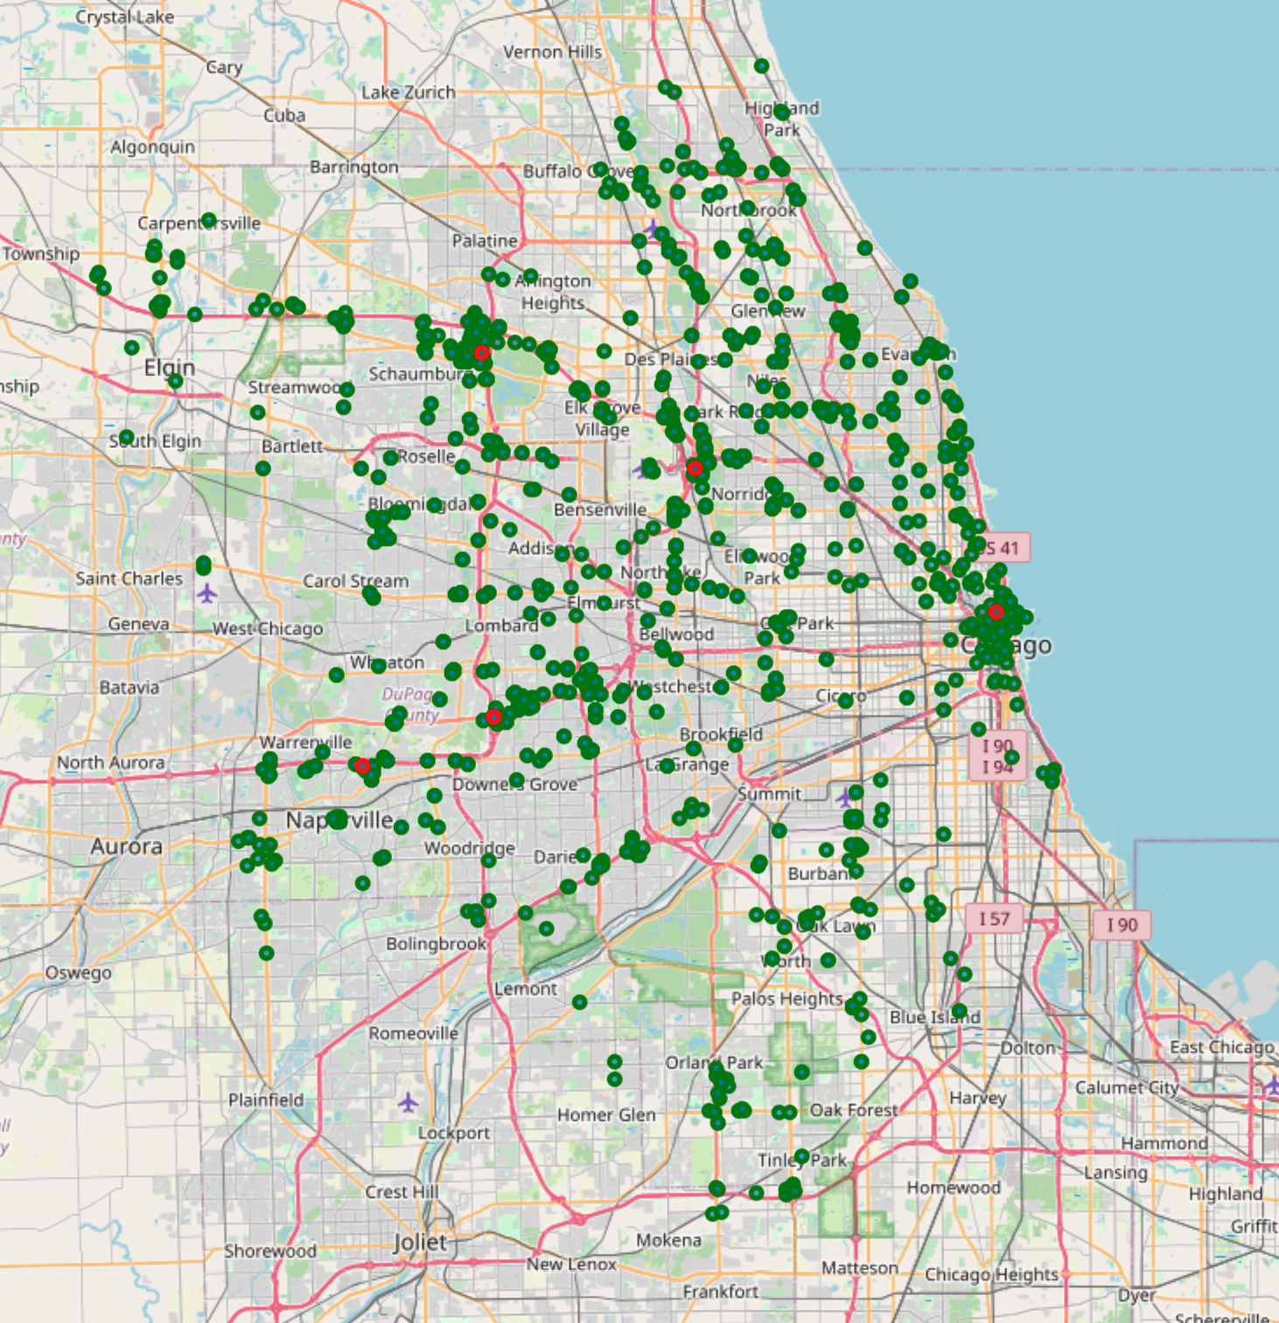

Figure 1: Brazilian steakhouses (red dots) in the metropolitan Chicago area.

The exploratory approach adopted here starts with a list of locations (could be zip codes, but I simply used city and town names), using default radius of 10,000 meters, fetching the following categories using the Foursquare API:

* Hotels
* Shopping Malls
* Steakhouses

Venues are de-duplicated based on venue ID, then the following steps are executed:

* Cluster with DBSCAN;
* Select a subset of the fields returned by the Foursquare API;
* Create a dataframe with onehot columns for venue categories;
* Add the cluster ID to the onehot dataframe;
* Aggregate onehot dataframe rows by cluster ID, calculating the sum of onehot variables along the vertical axis;
* Create a dataframe with cluster IDs and venue coordinates and calculate the centroids for each cluster;
* Concatenate the centroids and aggregation dataframes into a new dataframe “clusters”;
* Create a new dataframe with a subset of the aggregated onehot variables, and apply MinMaxScaler;
* Create a new dataframe with the “score”, which is the sum of the columns from the previous step;
* Create a new dataframe “scored_clusters” by concatenating clusters, scores and centroids;
* Sort the previous dataset by score in descending orderl
* Plot the final result placing the order in which top-N clusters should be considered for new restaurants inside “inverted tear drop” markers in red (starting with zero for the top recommendation).

The entire ranking process described above is encapsulated in a Python function named “rank_locations()”, which was used to analyze a few metropolitan areas as discussed in the next section.

Function “rank_locations()” returns four values:

* Venues dataframe
* Clusters dataframe
* Scored Clusters dataframe
* Map

One may further analyze the resulting values and repeat the process, adjusting parameters locations, prices, radius, epsilon, top_n and min_samples.

I found that setting epsilon to either 0.08 or 0.09 provided good results when applied to various metropolitan areas in the USA.

The notebook can be found at the following URL:

https://colab.research.google.com/drive/1NE2ezwBxA5gY5Fc-A09qiUMydlctLpve?usp=sharing

# Results

This section discusses the methodology as applied to different urban areas across the US.

## Metropolitan Chicago

The picture below shows an example of the result for the Chicago metropolitan area. Hundreds of venues were fetched from Foursquare. The clusters identified by DBSCAN are shown in various colors, and the recommended order in which those areas should be considered are show in red inverted tear drops.

Please note that clusters 0, 1, 2 and 3 match the locations for the Brazilian Steakhouses marked in red in the previous map. There were no Brazilian restaurants contained in the dataset downloaded from Foursquare using the specified critieria (hotels, shopping malls and steakhouses). Brazilian steakhouses must be queried with keyword “brazilian”, not “steakhouse” (for the most part….).

This is to show that the combination of the selected search criteria, the clustering algorithm and the scoring method are able to provide recommendations that match actual locations of Brazilian steakhouses, at least in the Chicago area.

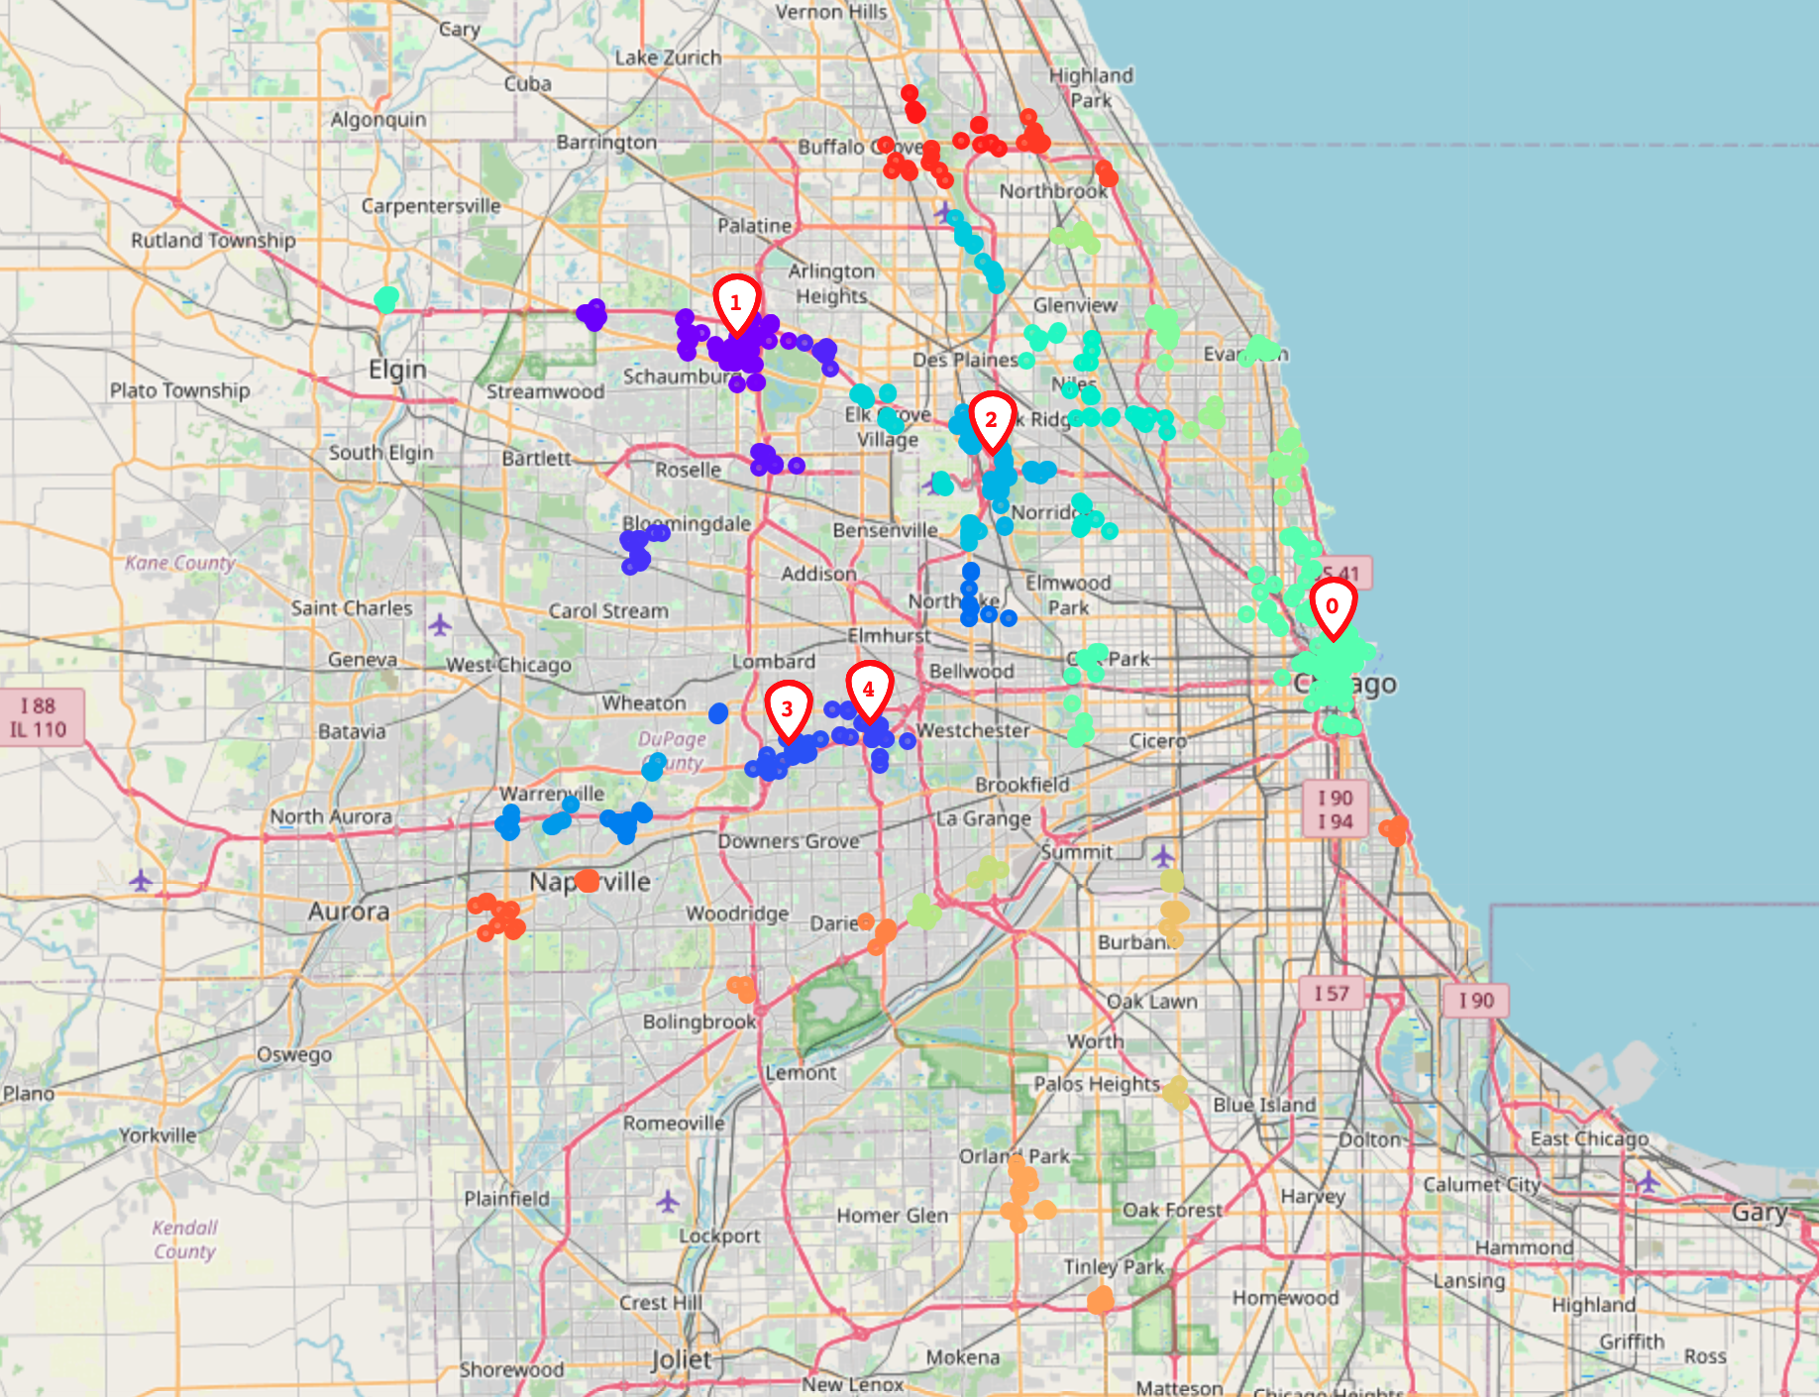

Figure 2: Ranked clusters in metropolitan Chicago.

The Python code for the previous map is show below:

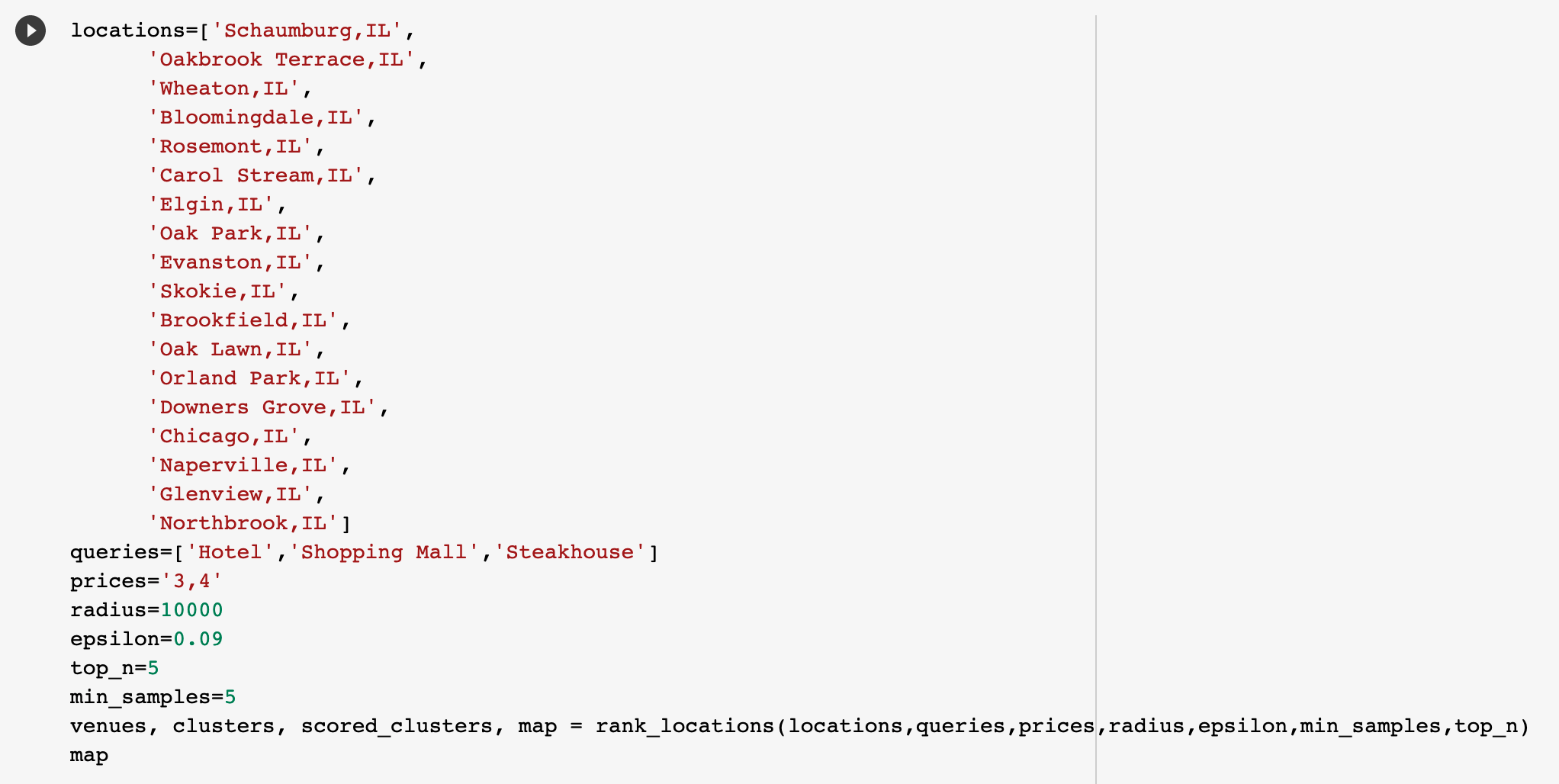

## Downtown Chicago

The results from Figure 1 show downtown Chicago as a single cluster, ranked at the highest position (zero). In order to drill into that area, I adjusted epsilon to 0.05 and min_samples per cluster to 2.

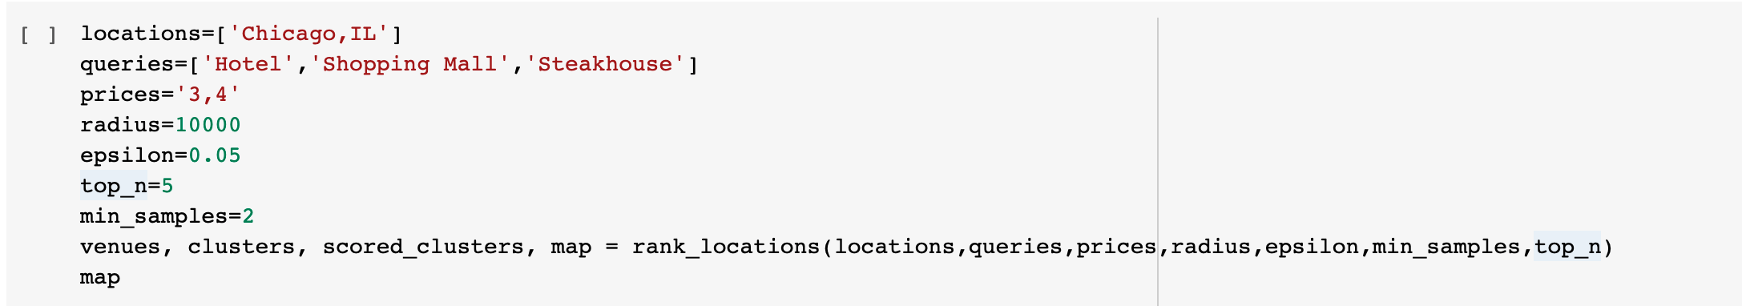

Interestingly the top recommendation (number zero) coincides with the location of the only Brazilian steakhouse present in downtown Chicago.

All recommendations are in areas north of the Chicago river, which corresponds to the entertainment district and the Gold Coast. There are clusters in the “Chicago Loop” (the financial district), but those did not rank high enough given the scoring method.

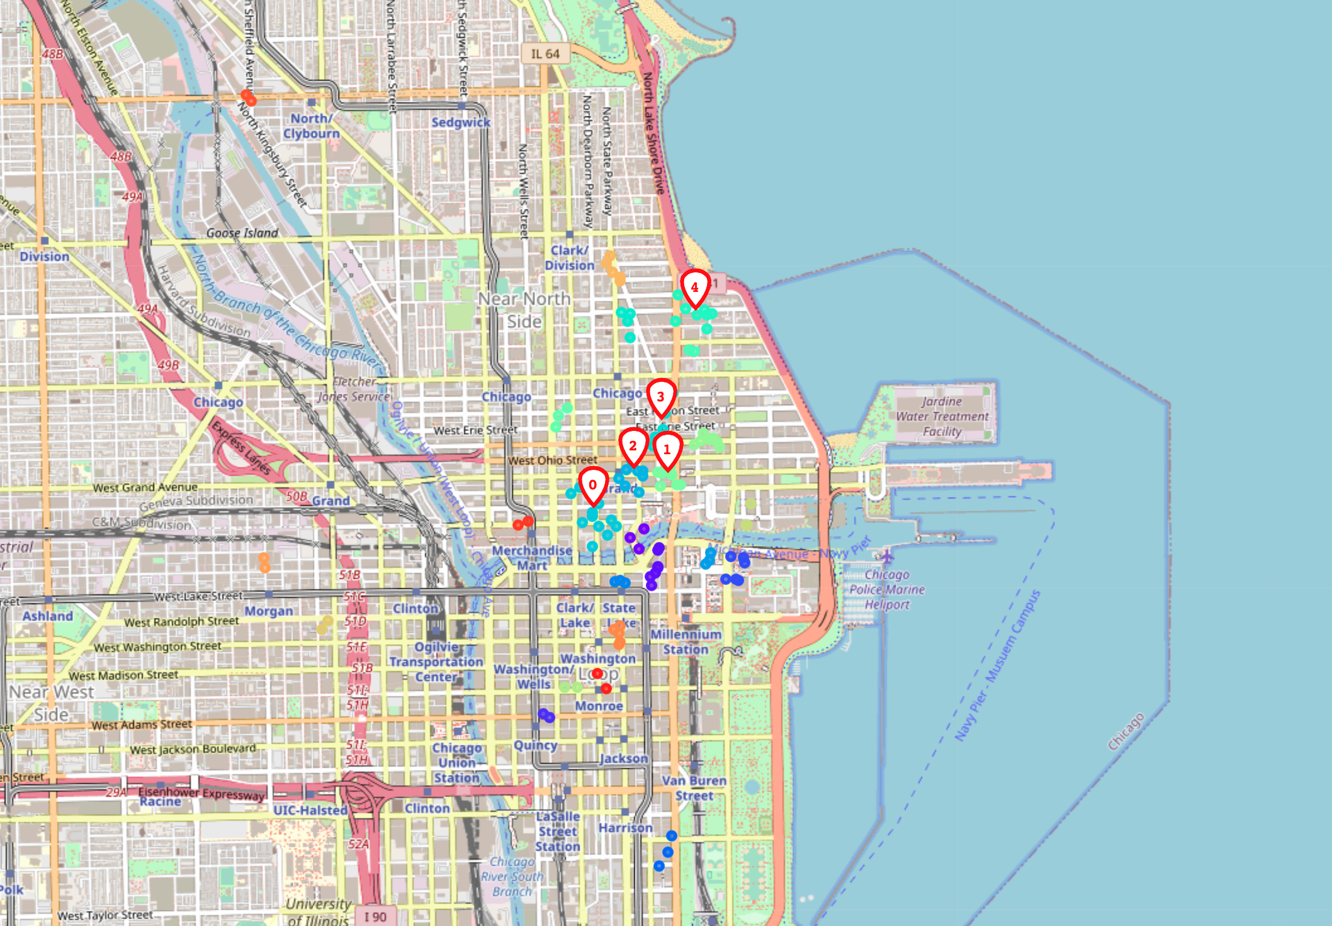

Figure 3: Ranked clusters in downtown Chicago.

## Downtown Manhattan

This section shows the code and recommendations for downtown Manhattan:

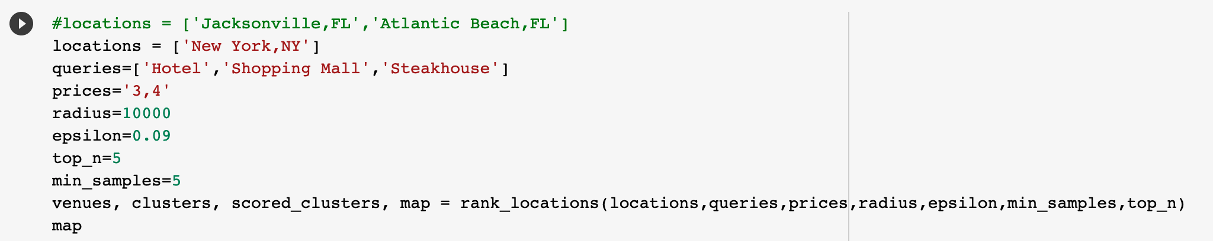

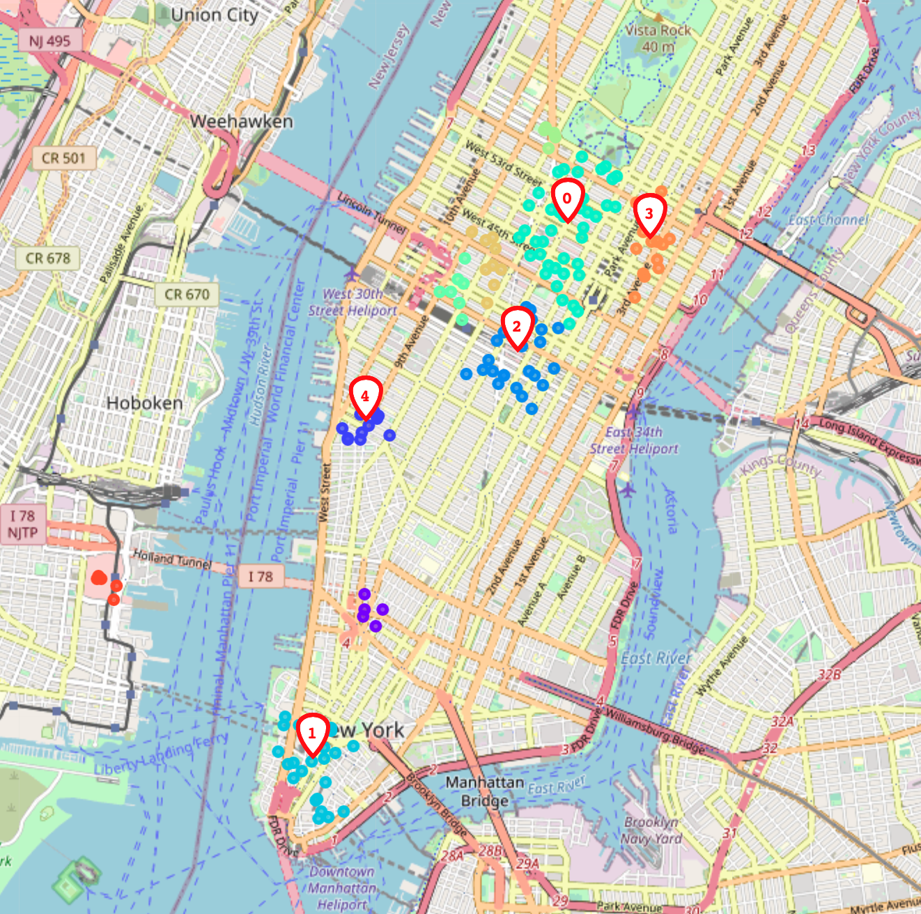

## Orange County

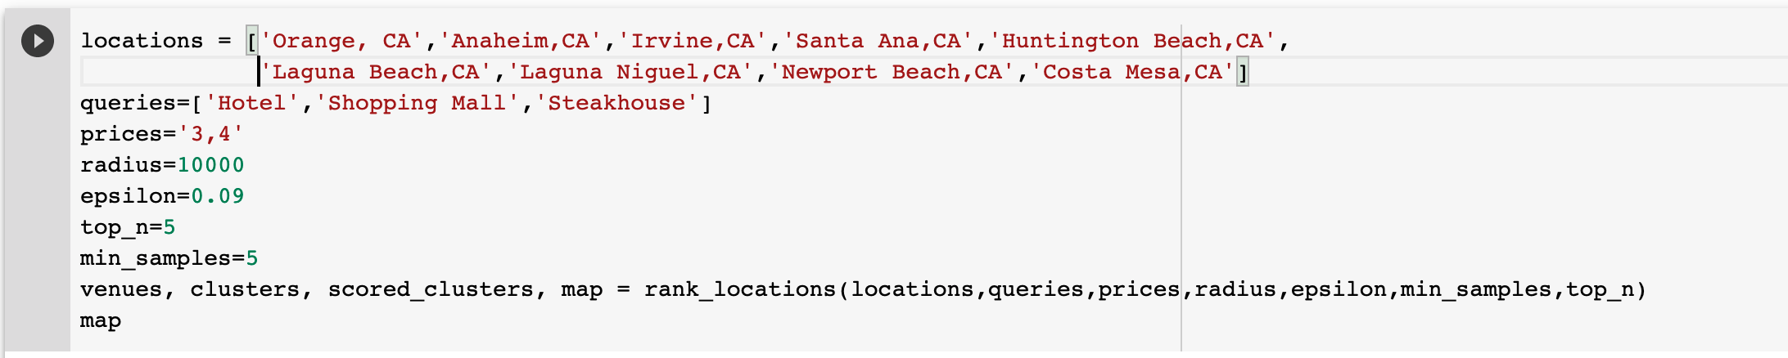

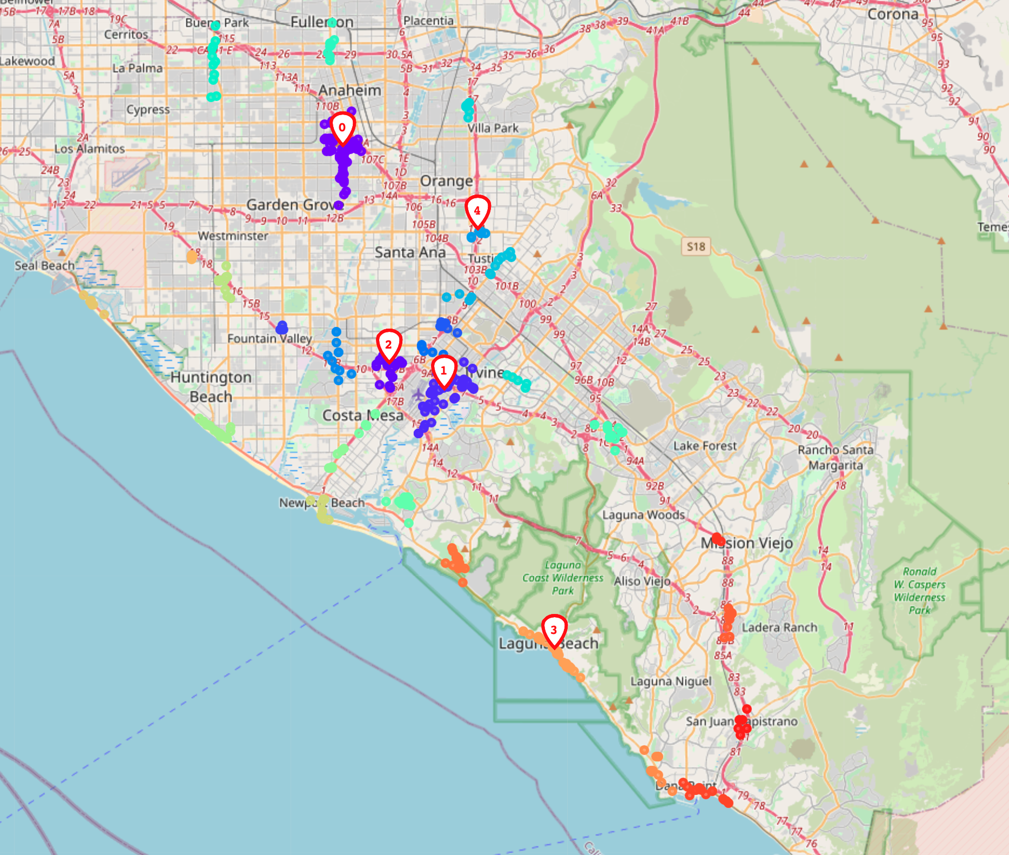

By including hotels and shopping malls, Laguna Beach was included in the top recommendations.

# Observations

A number of issues with the Foursquare API:

* The radius must be contained for denser result sets (10,000 seems a good trade-off);
* In some cases, categories don’t include results that should be present, while in other cases result sets include more items than expected:
* Known Brazilian steakhouses for the most part require specifying “brazilian” as part of the query string, but in some cases they can only be found when specifying “restaurant”.
* In some cases, “shopping mall” queries return not only a venue for the mall as a whole, but also individual stores within the mall, all with cetegory set to “Shopping Mall”;
* The price category is not as reliable as the “Michelin Stars”. It is highly relative and, of course, subject to crowd opinion. A restaurant that in one northern state in the moutain region is considered category 4, could be considered as an inferior category on another state;
* The Foursquare database seems for the most part stale, with old review dates. Makes one wonder how outdated the results really are. Can that be remediated by becoming a paying Foursquare customer?
* The developer API has limits on the number of premium calls, which makes it very hard to perform detailed analysis on customer feedback, using the Developer account.

Future analysis should include other types of data such as:

* customer reviews;
* income statistics;
* public transportation/traffic;
* crime stats;
* real estate and tax;
* etc.

# Conclusions

We achieved reasonable results using a standard clustering algorithm, DBSCAN, which identified potential areas based on the geographical distribution of certain types of venues.

The adopted scoring method (sum of MinMaxScaled aggregates of onehot variables) provided a simple yet effective way of sorting results.

The entire logic for the ranking process was encapsulated in a single reusable Python function, that may be leveraged and modified for future analysis.

It actually turns out to be a pretty good function that an actual restaurant chain could use when prospecting new locations. If I was to get into the restaurant business, it’s what I would actually rely on as a starting point.